**St. Anthony of Padua CWL Go Make a Difference**

1. St. Anthony of Padua CWL are continually focusing on endeavors to “**Go Make a Difference”.** These include projects on social isolation, care projects to the needy and homeless., many youth initiatives and endeavors to increase CWL membership as well as communication methods to our members and congregation.
2. **Our project for Catholic Education Week** involves the involvement of Catholic School students in our Diocesan Convention activities to be held May 6 and 7th. Elementary school students are providing the placemats and centrepieces for each table at our luncheon. Students from our local Catholic Schools will be responsible for the set up and clean up of the hall used for the convention and will provide entertainment for this event.

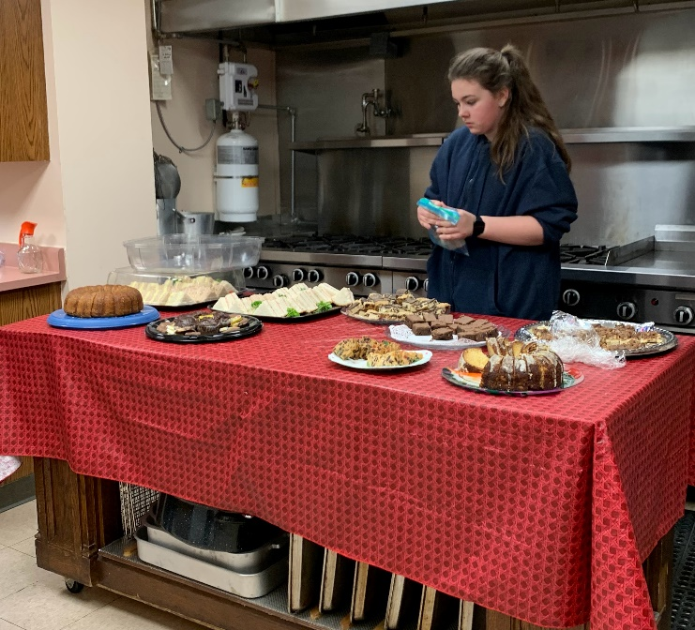

1. **Service Projects:**
2. St Anthony of Padua CWL is consistently attempting to institute ways to increase our membership. A CWL pamphlet outlining the function and mission of our CWL and a member is available at each mass to distribute these. Focus has been on involving our youth and, to date, we have enlisted one teen member.

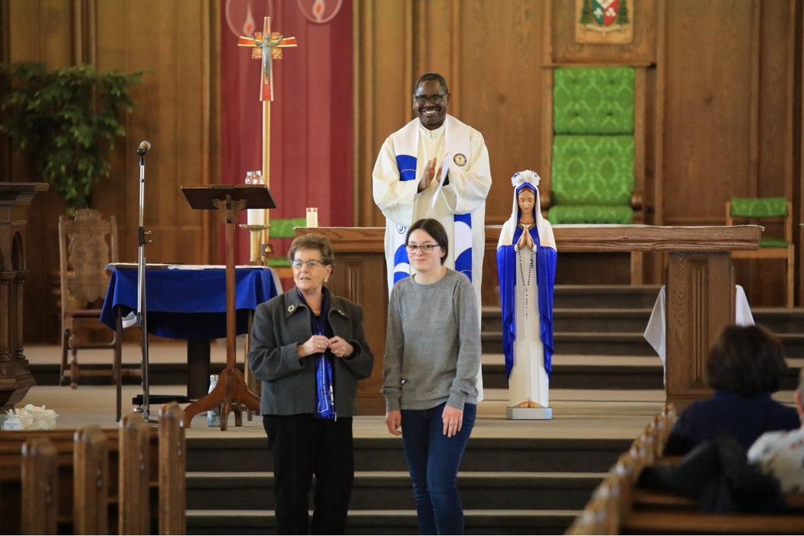

1. In the near future we will be providing a poster board to inform members, including potential members, and the congregation of our activities and accomplishments. Tis information board will be placed at the back of the church and will focus on visual as well as written information. Presently members receive information via a monthly newsletter and information in the church bulletin.

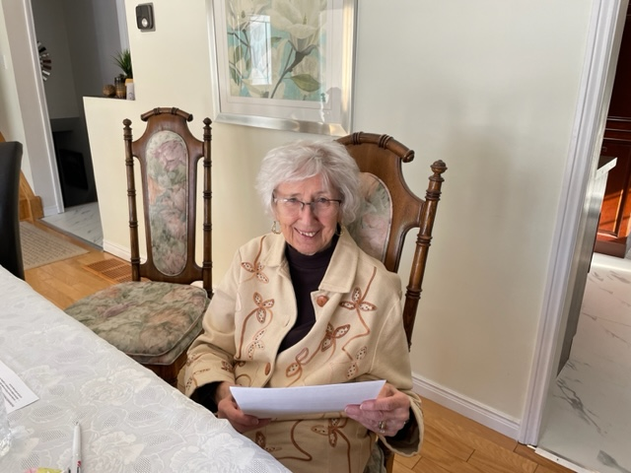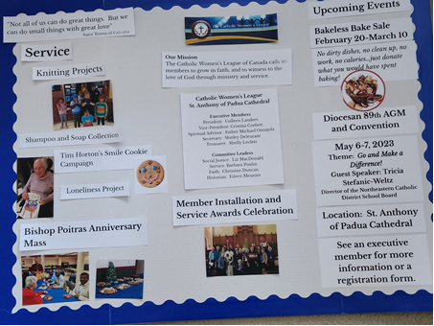

1. An **Annual “Awards Service”** provides recognition to our deceased members as well as service award to our members. This is provided through a beautiful service in the cathedral followed by a reception in the hall. (Youngest and 65-year member plus award winners at ceremony & social).

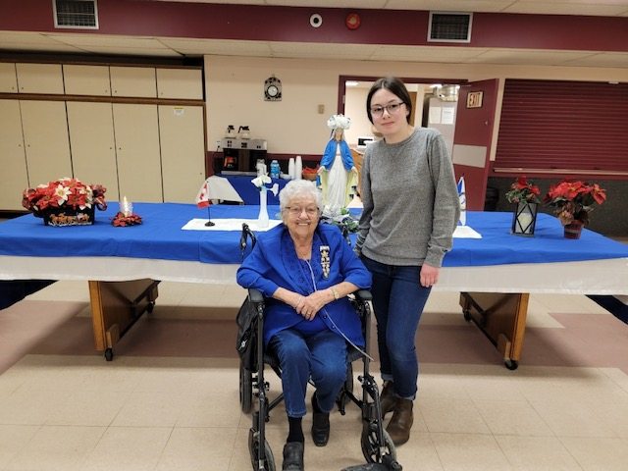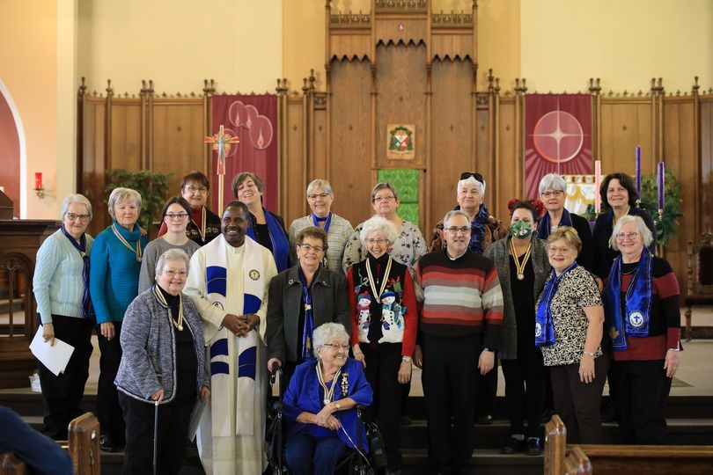

1. Projects have addressed our **socially isolated members**. Over two years ago, a plan was addressed to reach out to our socially isolate members. This was of particular concern during the Covid restrictions! Each month these members received a friendly phone call from a member. The calls continued until the restrictions were lifted but members were requested to notify the CWL of anyone continuing to require this service. Another project was “Project Loneliness”. For the past two Christmases, grade three students at Pope Francis prepared artwork and messages for identified members.

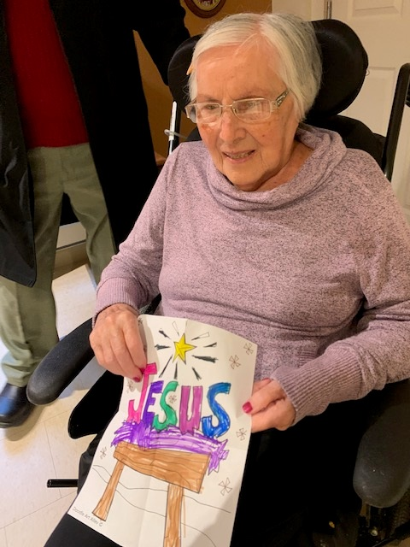

1. Some members continue to **assist new refugees** to our city. All of these newcomers require a friendly face and assistance with their move to our country and our city.

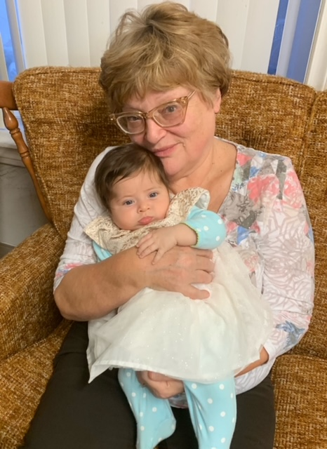

1. For the past two years, members have donated **wool and/or knitted toques, mitts or sweater**s for children in our schools. This project has been met with and overwhelming response and items not needy by these schools are distributed to the needy.

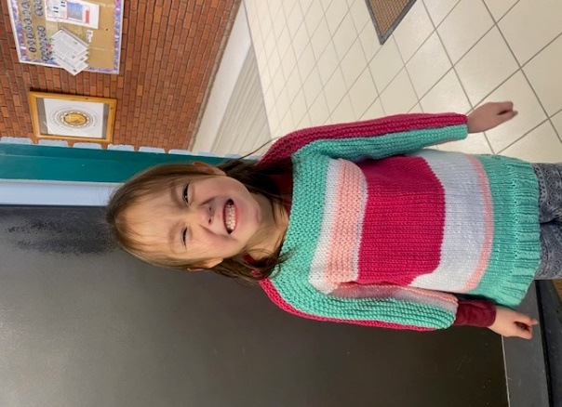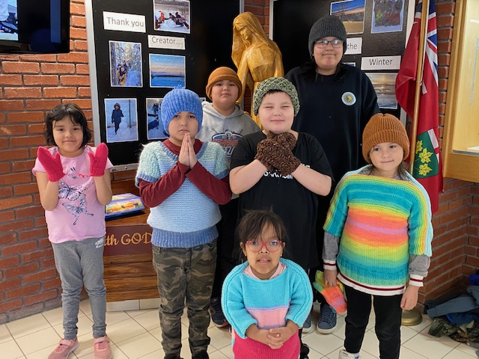

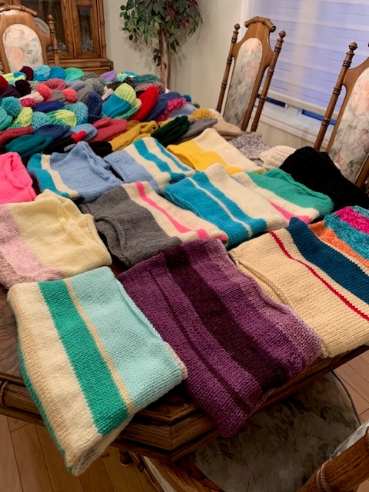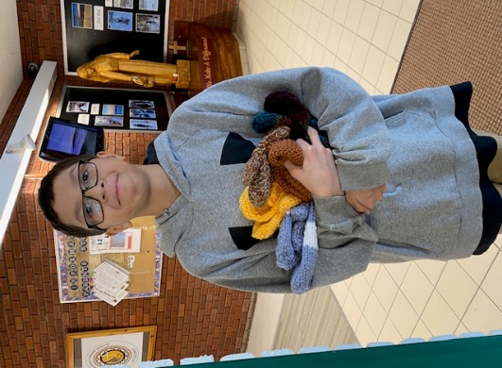

1. **Loneliness** was a primary topic of concern when this new Council began meeting. This was addressed by the monthly friendly phone call. Each month an average of 20 isolated members received a call and the number of calls was reported in each month’s report. After Covid restrictions were lifted and after these members requested that this service was no longer required, these call were stopped in July of 2021. In reports, members are encouraged to take some form of contact with socially isolated members, family or neighbours. The Pope Francis “Loneliness Project” has been highly successful with recipients. For the past two years, grade three students have prepared artwork and a Christmas message for identified members. This past year, 34 members received this very special gift! We are also aware that many individual members provide a visit or care to isolated people. Future endeavors will continue to be investigated and reported on.

Respectively Submitted by,

Barbara Poulin, St. Anthony of Padua CWL Education & Health (Service) Chair